**Instruction to Deploy model and run the codes**

**Please note :** It is written to write the instruction to deploy the model and not write the code to deploy the model. So will write the

Steps on how can we deploy the model.

**Deployment of Python code :**

Following are the few libraries and resources which will be used:

1. Pickle: It is a python library to save (serialize) and load (de-serialize) python objects as files on the disk.

2. Flask: It is a python based web framework.

3. pythonanywhere: A free to use educational website that allows hosting python flask and provides a complete python development environment.

Environment Setup: pip install the flask, flask_cors, jsonify and other python packages

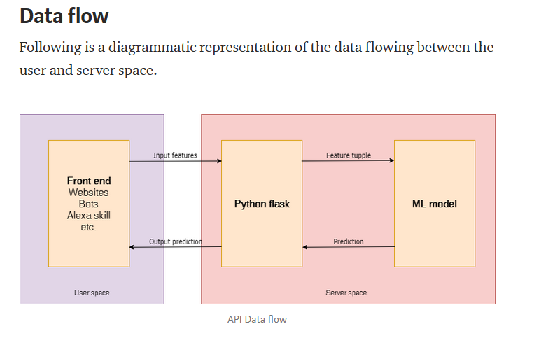

**Steps what need to be done as follows,**

1. Train the model using Jupyter notebook

2. Save the trained model as a pickle file (Serialization)

3. Create a flask environment that will have an API end point which would encapsulate our trained model and enable it to receive inputs through GET requests over HTTP/HTTPS and then return the output after de-serializing the trained model.

4. Upload the flask script along with trained model on pythonanywhere.

We already trained LightGBM model, so we will do serializing and de-serializing the trained model by using pickle package.

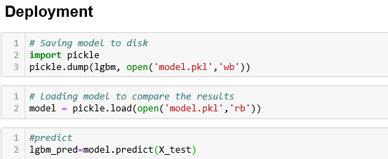

**Deployment of R code:**

Here we are using DeployR to demonstrate and plumber r package used to deploy the model.

DeployR It is an integration technology for deploying R analytics inside web, desktop, mobile and dashboard applications as well as backend systems.

**Basic work flow of DeployR** 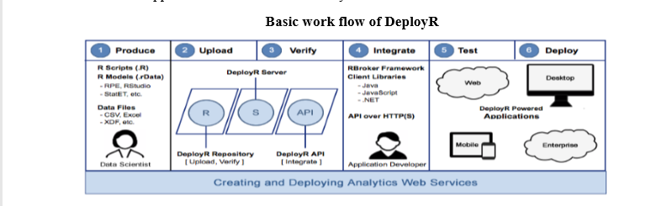

**The above diagram captures the basic work flow used by data scientists and application developers when collaborating on the delivery of solutions powered by Analytics web services.A data scientist develops an R script using standard R tools and publishes that script to deploy server, where it becomes available for execution as a analytics web service. Once published R scripts can be executed by any authorized application using DeployR. Plumber**

**Plumber an R package that convert existing R code to a web API by using a handful of special one line comments.**

